|  |  |
| --- | --- |
| File:COMSATS new logo.jpg - Wikimedia Commons  ***PROGRAMMING FUNDAMENTALS***  Lab Report 06 | **submitted by:**  **Shahzaneer Ahmed**  **registration number:**  **SP21-BCS-087**  **submitted to:**  **MR. RIZWAN RASHID**  **date of submission:**  **October 29,2021** |

# Exercise 01

## Source Code

// |----------------------------------------------------------|

// |------------------Shahzaneer Ahmed------------------------|

// |-------------------SP21-BCS-087---------------------------|

// |----------------------------------------------------------|

//Given two integers A and B (A ≤ B). Print all numbers from A to B inclusively.

import java.util.Scanner;

public class Exercise1 {

public static void main(String[] args) {

Scanner obj = new Scanner(System.in);

System.out.println("Enter the Starting value A :");

int a = obj.nextInt();

System.out.println("Enter the Ending value B :");

int b = obj.nextInt();

if (a>b){

System.out.println("Value A is smaller to B , counting not possible");

}

else if (a<=b) {

for (int i = a; i <= b; i++) {

System.out.println(i);

}

}

}

}

### ScreenShot

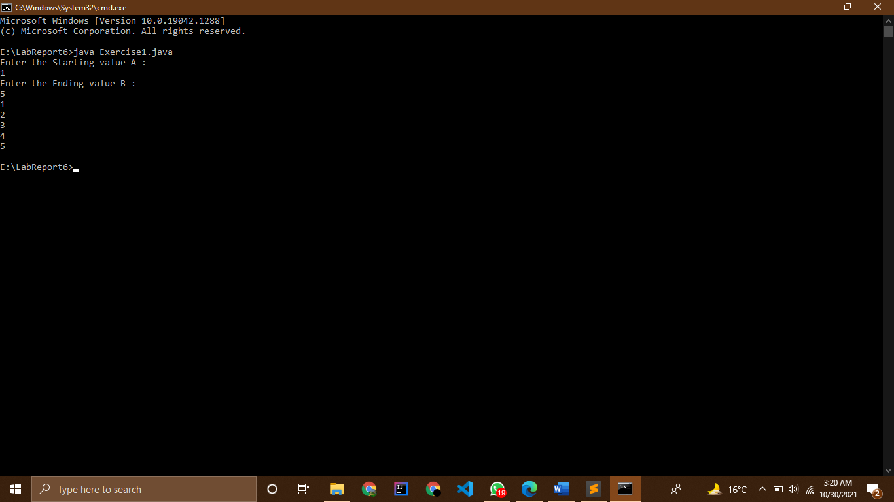

# Exercise 02

## Source Code

// |----------------------------------------------------------|

// |------------------Shahzaneer Ahmed------------------------|

// |-------------------SP21-BCS-087---------------------------|

// |----------------------------------------------------------|

//Given two integers A and B. Print all numbers from A to B inclusively, in ascending order, if A

//< B, or in descending order, if A ≥ B

import java.util.Scanner;

public class Exercise2 {

public static void main(String[] args) {

Scanner obj = new Scanner(System.in);

System.out.println("Enter the value for A :");

int a = obj.nextInt();

System.out.println("Enter the value for B :");

int b = obj.nextInt();

// same purpose k liay if aur while ikhattay use krne ki zarurat nhi!

// while loop simulation

while(a<b) {

System.out.println(a);

a++;

}

while (a>=b){

System.out.println(a);

a--;

}

// for loop simulation

// if (a<b){

// for (int i = a; i<=b;i++){

// System.out.println(i);

// }

// }

// else if (a>=b){

// for (int i = a; i>=b; i--){

// System.out.println(i);

// }

//

// }

}

}

### ScreenShot

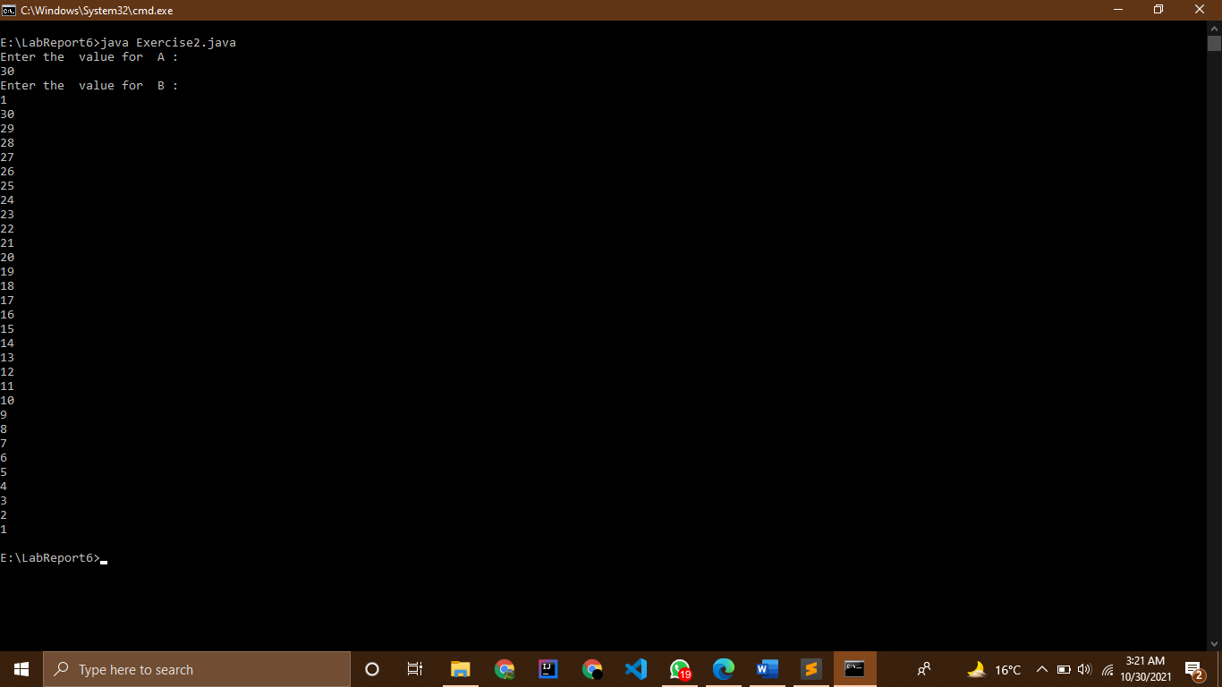

# Exercise 03

## Source Code

// |----------------------------------------------------------|

// |------------------Shahzaneer Ahmed------------------------|

// |-------------------SP21-BCS-087---------------------------|

// |----------------------------------------------------------|

//10 numbers are given in the input. Read them and print their sum. Use as few variables as

// you can.

import java.util.Scanner;

public class Exercise3 {

public static void main(String[] args) {

Scanner obj = new Scanner(System.in);

System.out.println("Enter 10 integers :");

int sum = 0;

int i = 1;

while (i<=10){

int integer = obj.nextInt();

sum+=integer;

System.out.println("Integer "+i +" is "+integer);

i++;

}

System.out.println("The sum is :"+sum);

}

}

### ScreenShot

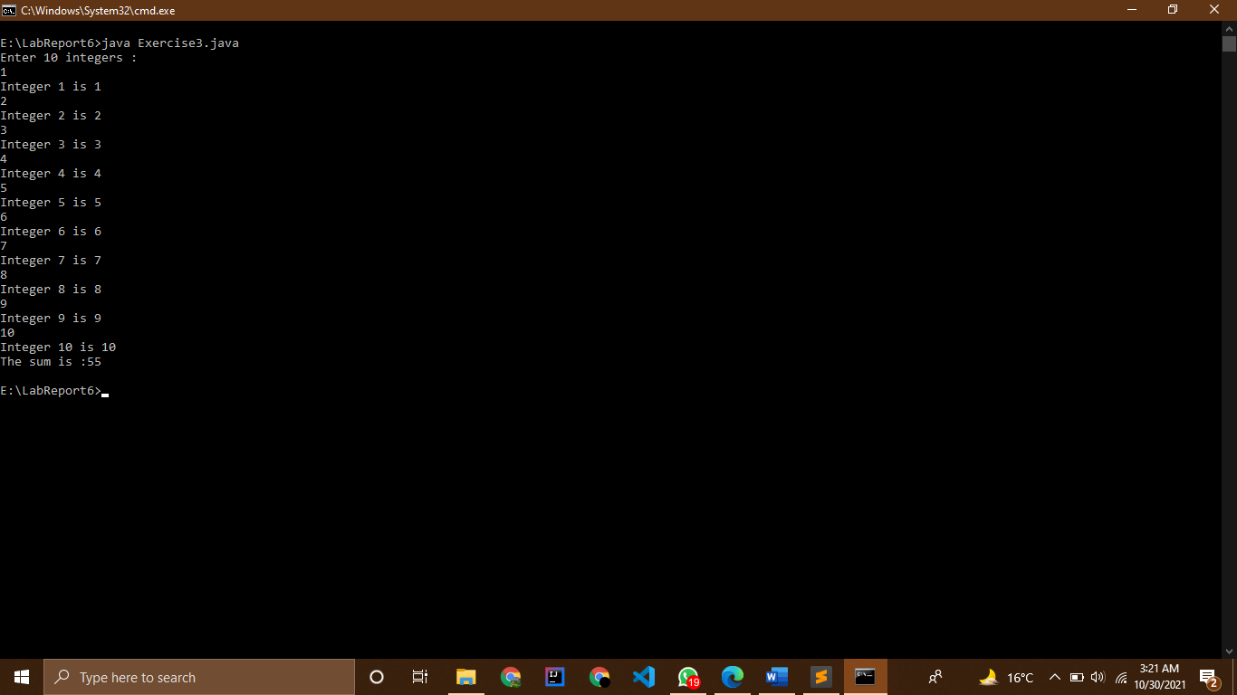

# Exercise 04

## Source Code

// |----------------------------------------------------------|

// |------------------Shahzaneer Ahmed------------------------|

// |-------------------SP21-BCS-087---------------------------|

// |----------------------------------------------------------|

//Sum of N numbers: N numbers are given in the input. Read them and print their sum.

// The first line of input contains the integer N, which is the number of integers to follow. Each

// of the next N lines contains one integer. Print the sum of these N integers.

import java.util.Scanner;

public class Exercise4 {

public static void main(String[] args) {

Scanner obj = new Scanner(System.in);

int sum = 0;

System.out.println("Enter No of natural :");

int n = obj.nextInt();

// have used array to display the elements entered!

// if we disable the array initialization, modification and printing statement the program will be still

// executable

int arr [] = new int[n];

int i = 0;

while(i<n){

int natural = obj.nextInt();

sum+=natural;

arr[i]=natural;

i++;

}

// System.out.print(arr);

System.out.println("The no of natural number are :"+n);

for (int j=0; j<n; j++){

System.out.println(arr[j]);

}

System.out.println("The sum is :"+sum);

}

}

### ScreenShot

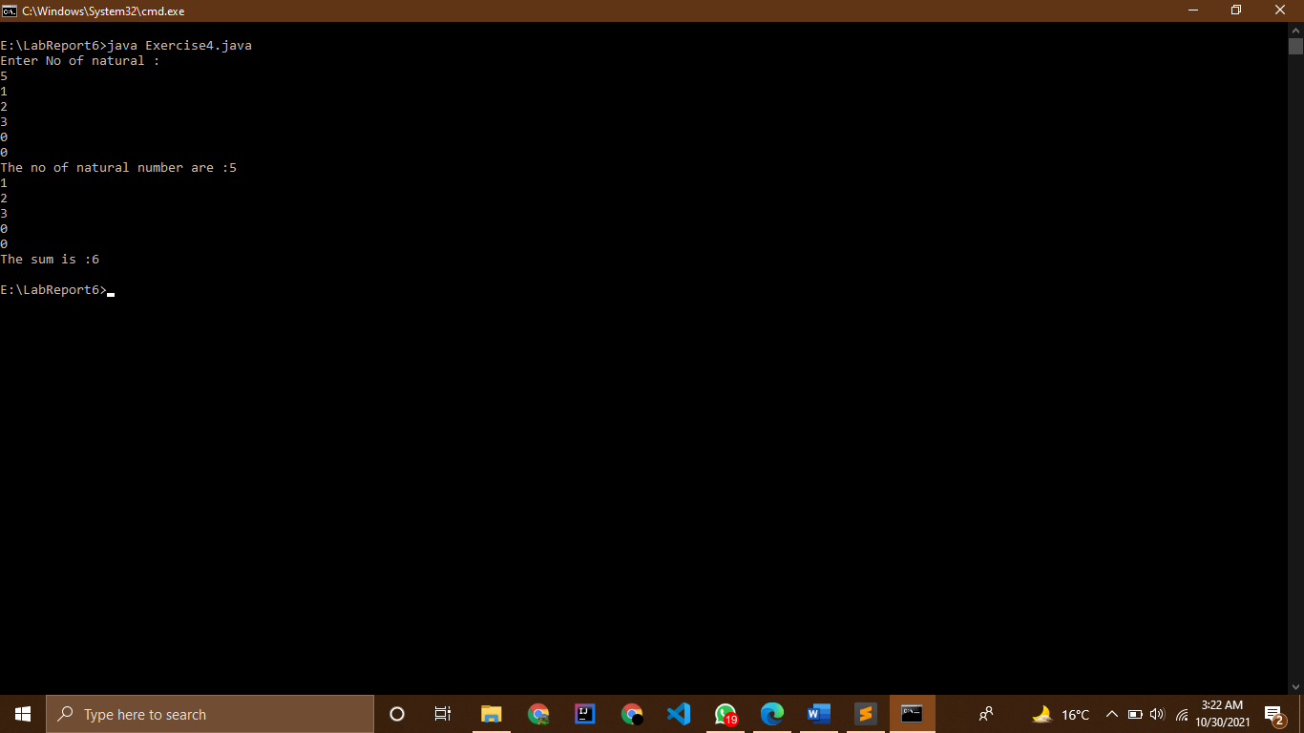

# Exercise 05

## Source Code

// |----------------------------------------------------------|

// |------------------Shahzaneer Ahmed------------------------|

// |-------------------SP21-BCS-087---------------------------|

// |----------------------------------------------------------|

//Sum of Cubes: For the given integer N calculate the following sum:

// 1

// 3

// +2

// 3

// +…+N

// 3

import java.util.Scanner;

public class Exercise5 {

public static void main(String[] args) {

Scanner obj = new Scanner(System.in);

System.out.println("Enter N till what you wanted to get sum of cubes :");

int num = obj.nextInt();

int sum = 0;

int i = 1;

// loop simulation

while (i<=num){

sum+=(i*i*i);

i++;

}

System.out.println("The sum of cubes is :"+sum);

// Mathematical Formula Simulation

// sum = ((num*num)*((num+1)*(num+1))/4);

// System.out.println("The sum of cubes is :"+sum);

}

}

### ScreenShot

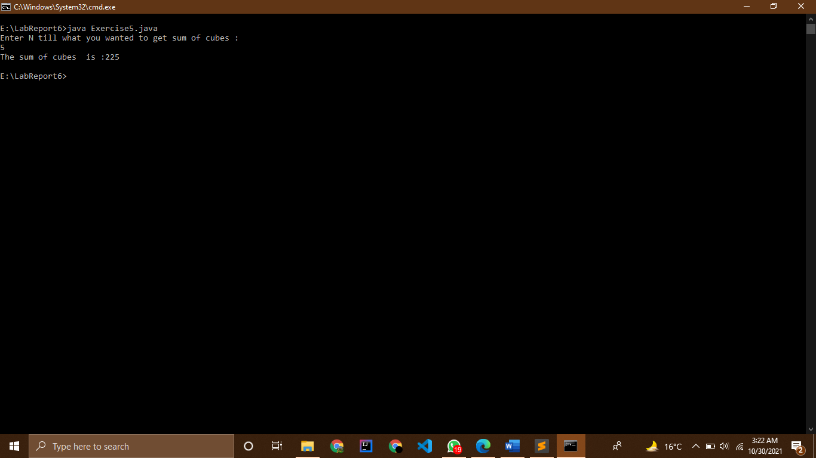

# Exercise 06

## Source Code

// |----------------------------------------------------------|

// |------------------Shahzaneer Ahmed------------------------|

// |-------------------SP21-BCS-087---------------------------|

// |----------------------------------------------------------|

//Factorial: In mathematics, the factorial of an integer n, denoted by n! is the following

// product:

// n!=1×2×…×n

// For the given integer n calculate the value n!

import java.util.Scanner;

public class Exercise6 {

public static void main(String[] args) {

Scanner obj = new Scanner(System.in);

System.out.println("Enter a positive number to find its factorial :");

int num = obj.nextInt();

if (num==0) System.out.println("The factorial of 0 is 0");

else {

int factorial = 1;

int i = num;

while (i >= 1) {

factorial *= i;

i--;

}

System.out.printf("The factorial of %d is %d", num, factorial);

}

}

}

### ScreenShot



# Exercise 07

## Source Code

// |----------------------------------------------------------|

// |------------------Shahzaneer Ahmed------------------------|

// |-------------------SP21-BCS-087---------------------------|

// |----------------------------------------------------------|

//Number of zeros: Given N numbers: the first number in the input is N, after that N integers

// are given. Count the number of zeros among the given integers and print it.

// You need to count the number of numbers that are equal to zero, not the number of zero

// digits.

// Input: 5 0 700 0 200 2 Output: 2

// Input: 6 0 0 0 0 0 0 Output: 6

import java.util.Scanner;

public class Exercise7 {

public static void main(String[] args) {

Scanner obj = new Scanner(System.in);

System.out.println("Enter the no of Integers you wanted to enter :");

int numbers = obj.nextInt();

System.out.println("Now please enter "+numbers +" Numbers");

int count = 0;

int i = 1;

while(i<=numbers){

int integer = obj.nextInt();

if (integer==0) count+=1;

i++;

}

System.out.println(count);

}

}

### ScreenShot

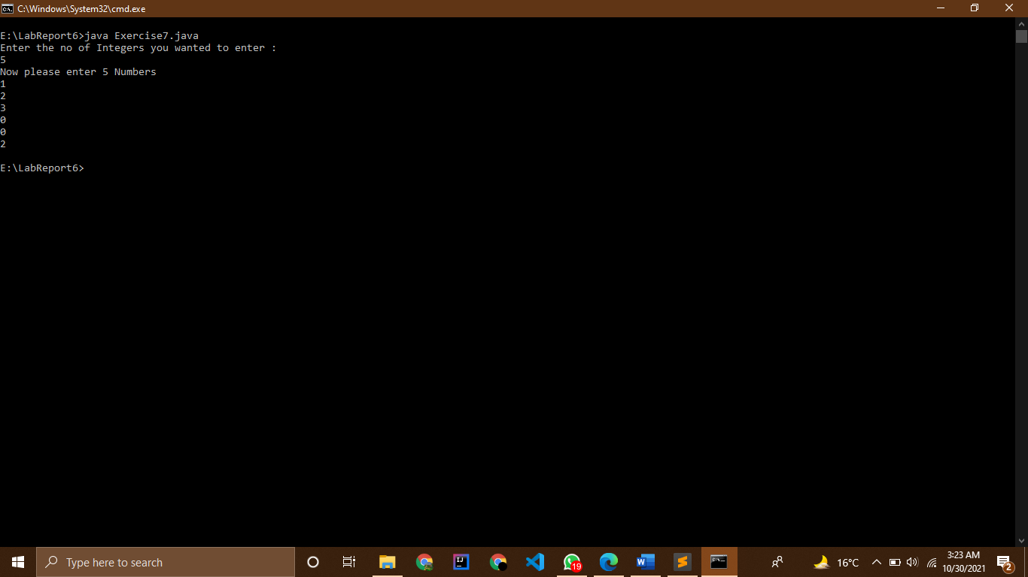

# Exercise 08

## Source Code

// |----------------------------------------------------------|

// |------------------Shahzaneer Ahmed------------------------|

// |-------------------SP21-BCS-087---------------------------|

// |----------------------------------------------------------|

//The length of Sequence: Given a sequence of non-negative integers, where each number

// is written in a separate line. Determine the length of the sequence, where the sequence ends

// when the integer is equal to 0. Print the length of the sequence (not counting the integer 0).

// The numbers following the number 0 should be omitted.

// Input: 1 2 3 4 5 6 7 0 1 2 3 Output:7

import java.util.Scanner;

public class Exercise8 {

public static void main(String[] args) {

Scanner input= new Scanner(System.in);

int number;

int length=0;

int maxLength=0;

System.out.print("Enter integers; -1 being the ending number: ");

do {

number=input.nextInt();

length= (number !=0 && number != -1)? ++length:length;

if (number == 0 || number == -1) {

maxLength= Math.max(maxLength, length);

length=0;

}

}while(number != -1);

System.out.println("Length of largest sequence: "+maxLength);

}

}

### ScreenShot

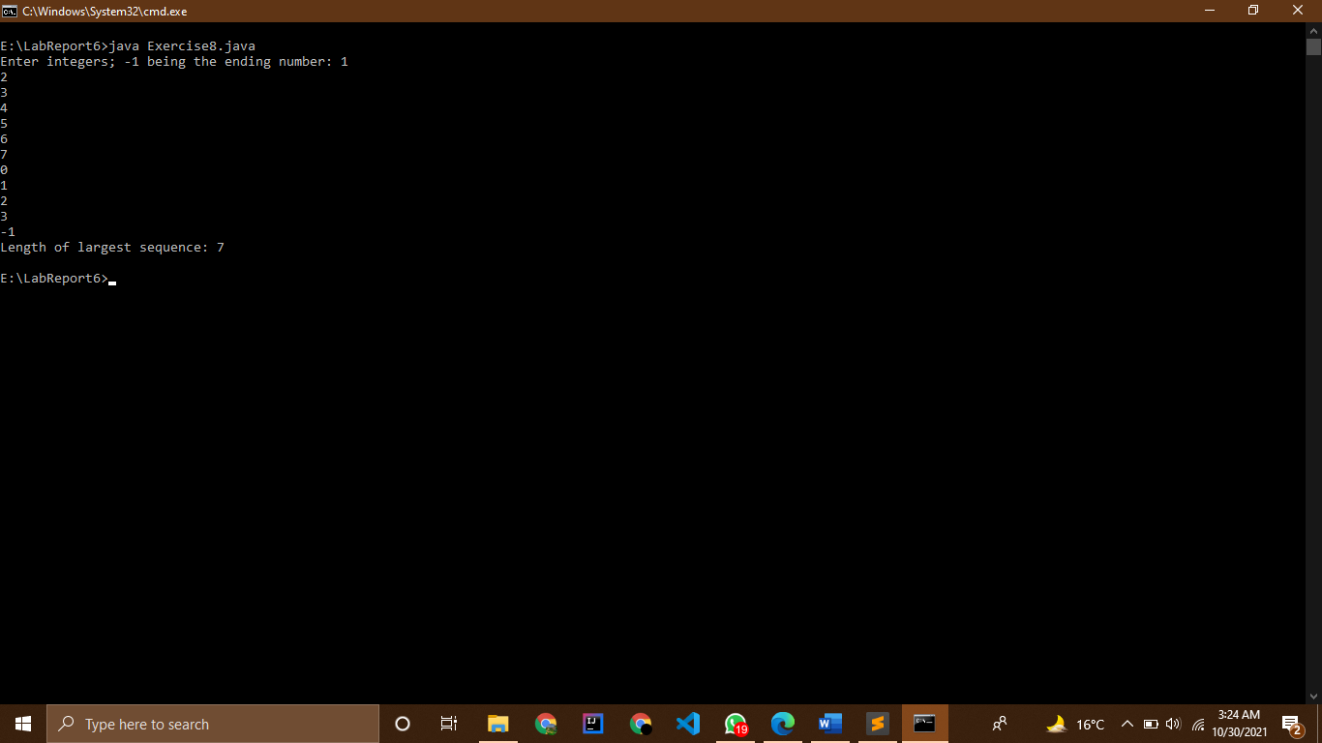

# Exercise 09

## Source Code

// |----------------------------------------------------------------|

// |--------------Shahzaneer Ahmed------------------------|

// |-------------------SP21-BCS-087---------------------------|

// |----------------------------------------------------------------|

//The maximum of the Sequence: A sequence consists of integer numbers and ends with

// the number 0. Determine the largest element of the sequence.

import java.util.Scanner;

public class Exercise9 {

public static void main(String[] args) {

Scanner input= new Scanner(System.in);

int number;

int max=0;

System.out.print("Enter integers; 0 being the ending number: ");

do {

number=input.nextInt();

if(number>max) {

max=number;

}

}while(number != 0);

System.out.println("Maximum of sequence: "+max);

}

}

### ScreenShot

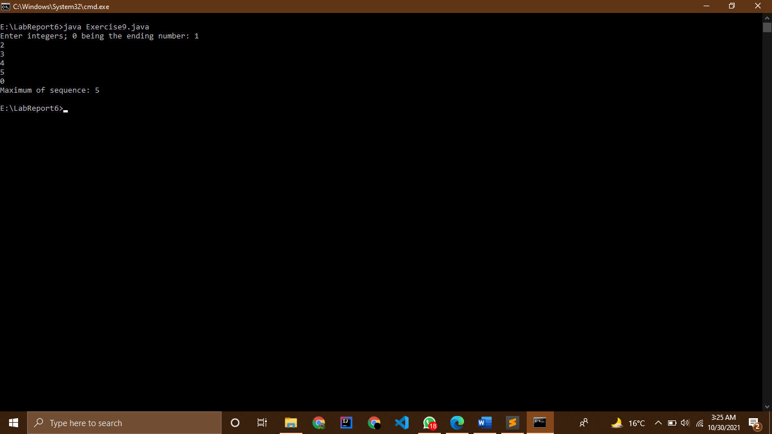

# Exercise 10

## Source Code

// |----------------------------------------------------------|

// |------------------Shahzaneer Ahmed------------------------|

// |-------------------SP21-BCS-087---------------------------|

// |----------------------------------------------------------|

//The index of the maximum of a sequence: A sequence consists of integer numbers and

// ends with the number 0. Determine the index of the largest element of the sequence. If the

// highest element is not unique, print the index of the first of them.

// Input:1 2 3 2 1 0 Output:3

import java.util.Scanner;

public class Exercise10 {

public static void main(String[] args) {

Scanner input= new Scanner(System.in);

int number;

int max=0;

int numIndex=0;

int indexOfMax=0;

System.out.print("Enter integers; 0 being the ending number: ");

do {

number=input.nextInt();

++numIndex;

if(number>max) {

max=number;

indexOfMax=numIndex;

}

}while(number != 0);

System.out.println("Maximum of sequence: "+max);

System.out.printf("Index of %d: %d",max,indexOfMax);

}

}

### ScreenShot

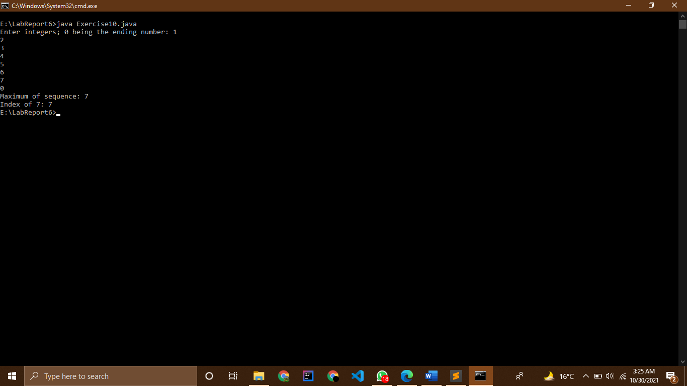

# Exercise 11

## Source Code

// |----------------------------------------------------------|

// |------------------Shahzaneer Ahmed------------------------|

// |-------------------SP21-BCS-087---------------------------|

// |----------------------------------------------------------|

//The number of even elements of the sequence: Determine the number of even elements

// in the sequence ending with the number 0.

import java.util.Scanner;

public class Exercise11 {

public static void main(String[] args) {

Scanner input= new Scanner(System.in);

int number;

int countOfEven=0;

System.out.print("Enter integers; 0 being the ending number: ");

do {

number=input.nextInt();

if(number%2==0 && number!=0)

countOfEven+=1;

}while(number != 0);

System.out.println("Number of even elements in sequence: "+countOfEven);

}

}

### ScreenShot

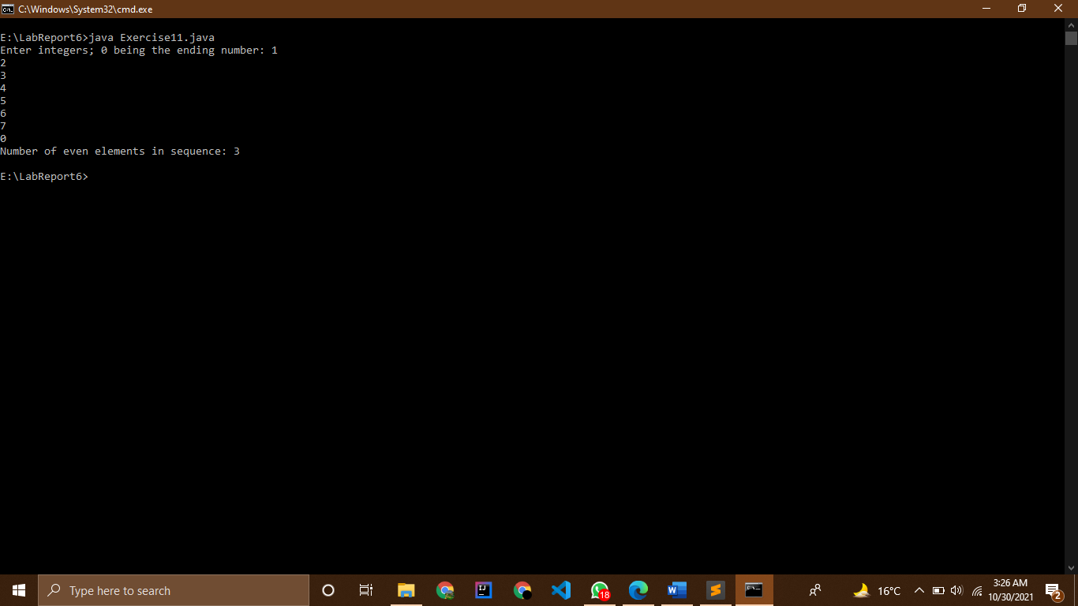

# Exercise 12

## Source Code

// |----------------------------------------------------------|

// |------------------Shahzaneer Ahmed------------------------|

// |-------------------SP21-BCS-087---------------------------|

// |----------------------------------------------------------|

//The number of elements that are greater than the previous one: A sequence consists of

// integer numbers and ends with the number 0. Determine how many elements of this

// sequence are greater than their neighbours above.

// Input: 1 5 2 4 3 0 Output:

import java.util.Scanner;

public class Exercise12 {

public static void main(String[] args) {

Scanner input= new Scanner(System.in);

int number;

int prevNumber=0;

int count=-1;

System.out.print("Enter integers; 0 being the ending number: ");

do {

number=input.nextInt();

if((number > prevNumber) && (number != 0))

count++;

prevNumber=number;

}while(number != 0);

System.out.println("Elements greater than their neighbour above: "+count);

}

}

### ScreenShot

